Rachel Mast
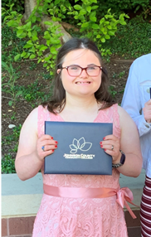
September 28, 2022
KS IDD Modernization Task Force

Dear Committee Members:

My name is Rachel Mast. I am 23 years old. I live in City. I am a patient greeter at KU Med. I love my job.

Every year, we meet with people I do not know to do the BASIS. It makes me very anxious and nervous. I have to talk about private things with them. It is embarrassing. It makes me sad. It makes me cry. It does not talk about the things I am good at. It does not say anything about my smile or how hard I work or that people say that I am good at comforting others. It does not say that I love my life. It makes me feel like people do not think I am smart.

I love my job at KU Health System. It is hard to get there. I started taking Ride KC Freedom. I have been late three times. Yesterday, they did not ever show up. This makes me anxious. I want to be a good employee. Some afternoons, I wait over an hour for them. Afternoons are the worst. It may take two hours to get home. There is not an app. I can use an app. If I had an app I could see when they are coming.

I helped to pass the ABLE Act. I testified before the Kansas Children and Seniors committee. I opened the first Kansas ABLE Savings Account. That makes me very proud.

I love my life. I want to get married and live in a pink house. I need help to do that. I do not think the BASIS is a good way to decide to help me. I should not be treated this way just because I need help to live my dreams.

Thank you.

Rachel Nicole Mast
Adress
City, State, Zip Code
Phone: (xxx) xxx-xxx
Email:

This is a link to my video testimony - https://youtu.be/Xm3fPNCCMW8

