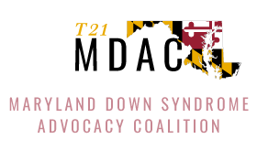
Gabby Fleming
Public Comment
Meeting of the Maryland State Board of Education, June 27, 2023

Hi, my name is Gabby Fleming, and I want to tell you my story of inclusion. I just graduated from Walt Whitman High School in Montgomery County with a certificate. When I was a little girl, I went to preschool in Israel and Oman. When we moved to Bethesda for first grade, I went to three schools before I finally could go to my home school where I could walk to school with my sister and my neighbor friends. It was so fun.

In elementary school I sang in the choir and ran in Girls on the Run. In the summer, I saw my friends at YMCA camps and at the pool for summer swim team. We all grew up together.

High school was a magical experience. I was in high school for six years. I’m so grateful to all of my friends and teachers.

My Living for Independence (LFI) teachers were good teachers to me. I loved making new friends. I also took classes like ASL and Spanish. I loved music technology and PEP Band and Best Buddies. My favorite memories are singing in Whitman Idol, dancing on the baseball field at Homecoming, and winning at Bocce.

It was So. MUCH. FUN!!!

It is so important to be a leader in your community. I am a leader of kindness and spirit. My community is full of people who are kind and who include me. Inclusion isn’t just my story—it's OUR story.

I wish for every child to know they belong in their home schools, with their siblings and their neighbors, to be a part of their communities. Thank you for letting me tell you my story.

