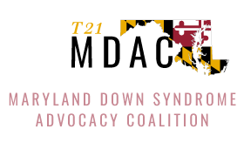
Meeka Caldwell
Public Comment
Meeting of the Maryland State Board of Education, July 29, 2025

My name is Meeka Caldwell and I’m the proud parent of Anian—an energetic, fun, and smart 11-year-old, who has been a part of this district since kindergarten. He is going into 6th grade! And ever since then, we’ve been fighting for something simple, but far too rare: his right to learn, to belong, and to be included.

Anian really enjoys school. He loves riding the bus. He loves walking the hallways. He loves being with his friends. But the system has not loved him back—not with the consistency, dignity, or opportunity that he deserves.

In 4th grade, there was no special educator assigned at his neighborhood school, so his IEP wasn’t followed. We fought through due process and mediation. We were granted nonpublic placement. But “placement” is meaningless when schools are full or unwilling to accept your child. We were left on our own—homeschooling.

When we returned to public school in 5th grade, it was because Anian wanted to go back. Because he wanted what every child wants: to be seen, to be included, to learn. We chose a school with a Community Referenced Instruction program, believing it would offer access to curriculum and community. But instead, Anian was placed in a self-contained classroom for months—despite what his IEP said. The excuse? “He’s on the alternate curriculum.” But the alternate curriculum does not mean isolation—and it should never be used that way.

His speech therapy came through Zoom. His occupational therapy wasn't targeted for his needs. His work was far from challenging. We paid out of pocket for an advocate, sat in meeting after meeting, and asked for inclusion in general education with appropriate modifications. Instead, he was placed in the back of a math class, with his aide—separated from instruction, separated from his classmates. Present in body, excluded in every other way. This is not inclusion. This is invisibility.

So tonight, I want to be clear about what our kids need to succeed—not just Anian, but thousands like him across this district:

1. High expectations.
Teachers must believe our children can learn. That belief must show up in IEPs—with rigorous, meaningful, individualized goals. Our children should be challenged, not pitied or written off.

2. Educators who are prepared.
Both general and special education teachers need the knowledge, tools, and skills to support inclusive classrooms. And just as important—they need time to collaborate. Inclusion can’t be effective if teams are working in silos.

3. Resources—and smart deployment of them.
Our schools need enough special educators, related service providers, and aides. But we also need those staff placed where they’re most needed, supporting inclusion—not managing containment.

4. Systems that prioritize placement in general education classrooms—because that’s where our kids belong. With their friends. With their siblings. With their community. That’s what inclusion means.

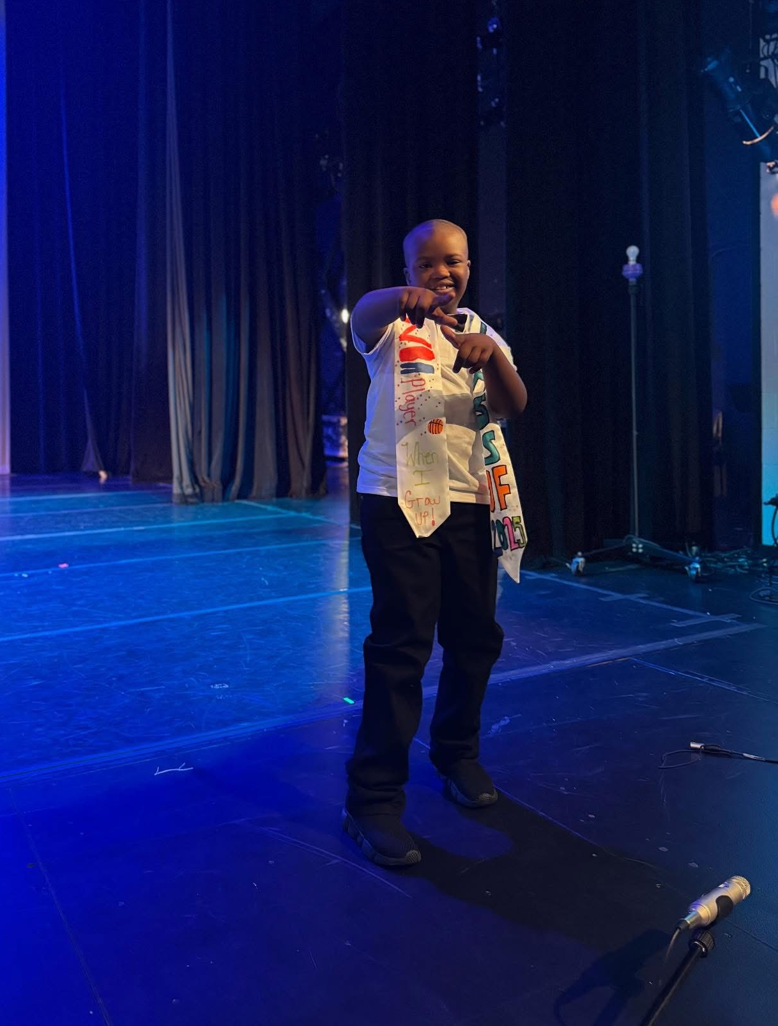
We’re not here asking for favors. We’re asking for what’s already required—and what’s morally right. And we are not asking blindly. We know what works.

We’ve seen moments of progress, moments of real inclusion. But they’re too few, too fragile, and too dependent on individual educators going above and beyond without support.

The Special Education Workgroup gave you a roadmap. The recommendations are clear. Now it’s time to act. Implementation can’t be delayed. Our kids are in school now. They can’t wait.

Anian deserves better.

Every child does.
We are ready for change. That's really it, and we've been ready without movement for way too long.

